# Punch In:

When you perform a Punch IN, the Time Clock Device records the current time and the function key pressed. Please use the following steps to punch IN using the keypad:

* Press the “In” button on the key pad

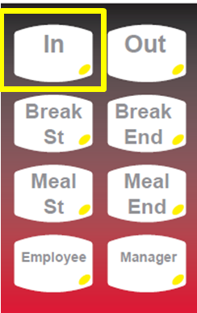

* On the Screen you will see:

IN for day

Enter Employee ID:

->

* The **Employee** will enter their Employee ID using the keypad.

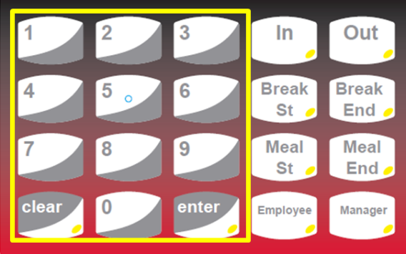

* Once the **Employee** has entered their Employee ID, press the Enter button on the keypad

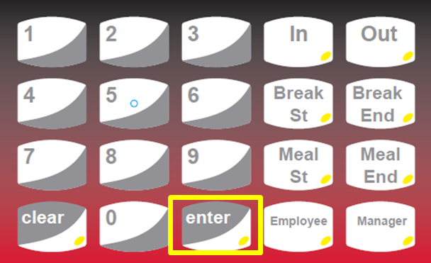

Place finger on

reader

* Place finger on the scanner until scan is complete
* A message will be displayed indicating the IN Punch has been accepted.

Punch Accepted

Thank you

**Punch Out For Meal:**

When you perform a Meal Punch the Time Clock Device records the current time and the function key pressed. Please use the following steps to punch out for a meal using the keypad:

* Press the “Meal Start” button on the keypad

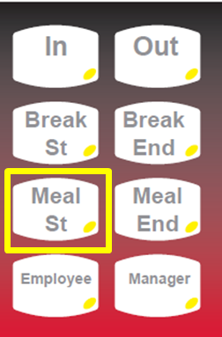

* On the Screen you will see:

Meal Start

Enter Employee ID:

->

* The **Employee** will enter their Employee ID using the keypad.



* Once the **Employee** has entered their Employee ID, press the Enter button on the keypad



Place finger on

reader

* Place the finger on the scanner until scan is complete
* The employee will get a message stating they have successfully punched out for a meal.

Punch Accepted

Thank you

**Punch IN From a Meal:**

* Press the “Meal End” button on the keypad

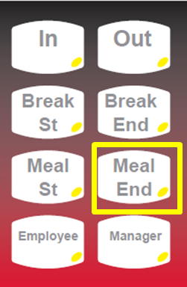

* On the Screen you will see:

Return From Meal

Enter Employee ID:

->

* The **Employee** will enter their Employee ID using the keypad.



* Once the **Employee** has entered their Employee ID, press the Enter button on the keypad



Place finger on

reader

* Place finger on the scanner until scan is complete
* The employee will get a message stating they have successfully punched IN from a meal

Punch Accepted

Thank you

**Punch Out:**

When you perform a Punch OUT, on the Time Clock Device records the current time and the function key. Please use the following steps to punch out using the keypad:

* Press the “Out” button on the keypad

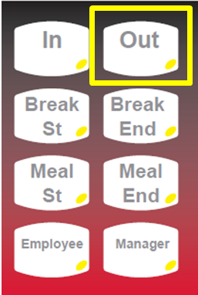

* On the Screen you will see:

OUT for day

Enter Employee ID:

->

* The **Employee** will enter their Employee ID using the keypad.



* Once the **Employee** has entered their Employee ID, press the Enter button on the key pad



Place finger on

reader

* Place the same finger on the scanner until scan is complete
* The clock will then look to see if there is a lunch punch in the system

….verifying lunch

* If a lunch punch is found the clock will just accept the Out punch
* If a lunch punch is not found the clock will prompt the employee

No lunch transaction

Did you take a lunch today?

Press 1 for Yes

Press 2 for No

* Select either 1 or 2
* The employee will get a message stating they have successfully punched out.

Punch Accepted

Thank you